

# Install SonaType Nexus 3 On Ubuntu 20.04 LTS

I was reading several tutorials about him, I made several attempts, I was beaten all the time and I will show you the way it should be.

**Mandatory Packages**

OpenJDK 1.8

Before install Java

sudo apt-get install openjdk-8-jdk

sudo apt-get update

**Java**

sudo apt-get install openjdk-8-jdk

Execute the below commands — navigate to /opt directory by changing directory:

**Download Nexus**

<http://download.sonatype.com/nexus/3/nexus-3.22.0-02-unix.tar.gz>

**Extract Nexus**

sudo tar -xvf [latest-unix.tar.gz](https://download.sonatype.com/nexus/3/latest-unix.tar.gz)

sudo mv latest-unix nexus

**Create a user called Nexus**

sudo adduser nexus

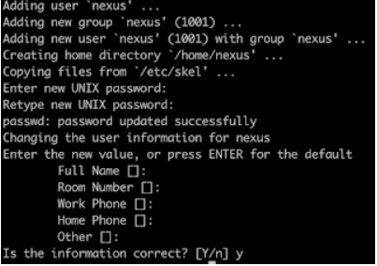

sudo adduser nexus

Give some password may be as admin, but do remember.

Keep entering enter for all other values and press y to confirm the entries.

**Give permission to Nexus user**  
sudo chown -R nexus:nexus /opt/nexus  
sudo chown -R nexus:nexus /opt/sonatype-work

sudo vim /opt/nexus/bin/nexus.rc

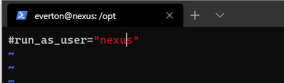

change run_as_user=”nexus”

**Modify memory settings**

sudo vim /opt/nexus/bin/nexus.vmoptions

Add all the below changes the file with below highlighted entry:

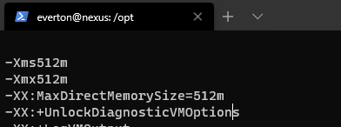

**Configure Nexus to run as a service**  
sudo vim /etc/systemd/system/nexus.service  
Copy the below content.

[Unit]  
Description=nexus service  
After=network.target

[Service]  
Type=forking  
LimitNOFILE=65536  
User=nexus  
Group=nexus  
ExecStart=/opt/nexus/bin/nexus start  
ExecStop=/opt/nexus/bin/nexus stop  
User=nexus  
Restart=on-abort  
[Install]  
WantedBy=multi-user.target

**Now Start Nexus**

sudo systemctl enable nexus

sudo systemctl start nexus

sudo systemctl status nexus

If it says stopped, review the steps above and you can troubleshoot by looking into Nexus logs by executing below command:

**tail -f /opt/sonatype-work/nexus3/log/nexus.log**

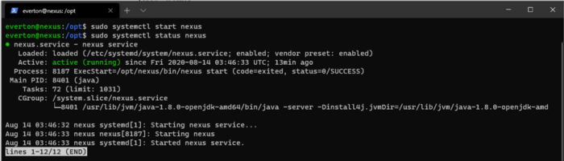

Once Nexus is successfully installed, you can access it in the browser by

URL — [http://public_dns_name:80](http://public_dns_name:8081/)81

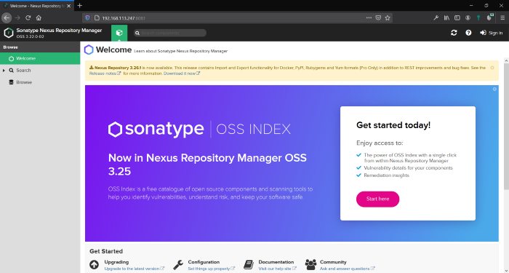

Sonatype Nexus

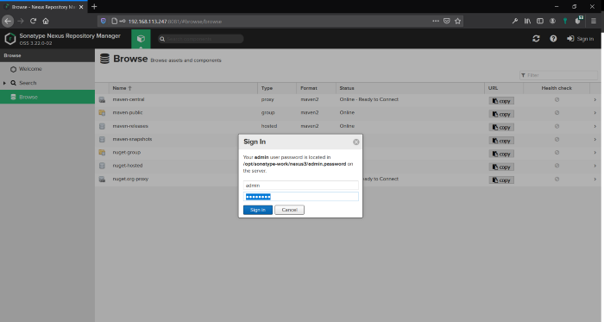

the instruction is below.

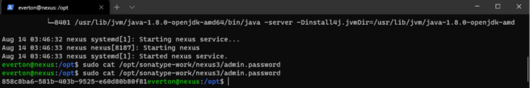

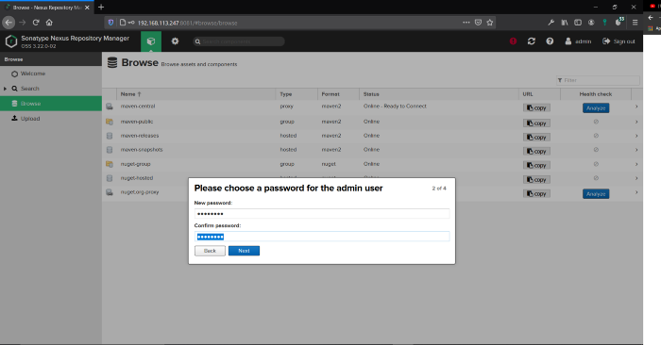

change password please

